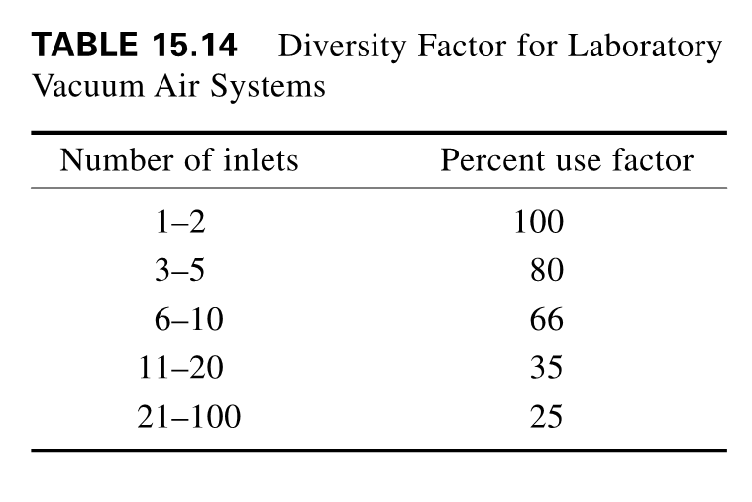

Source:

Frankel, M. (2002). *Facility Piping Systems Handbook*. 2nd ed. New York: McGraw-Hill.